Private Richard Brandtonies
Company B, 1st Battalion, 116th Infantry Regiment, 29th Infantry Division
Omaha Beach

Draft Registration Card
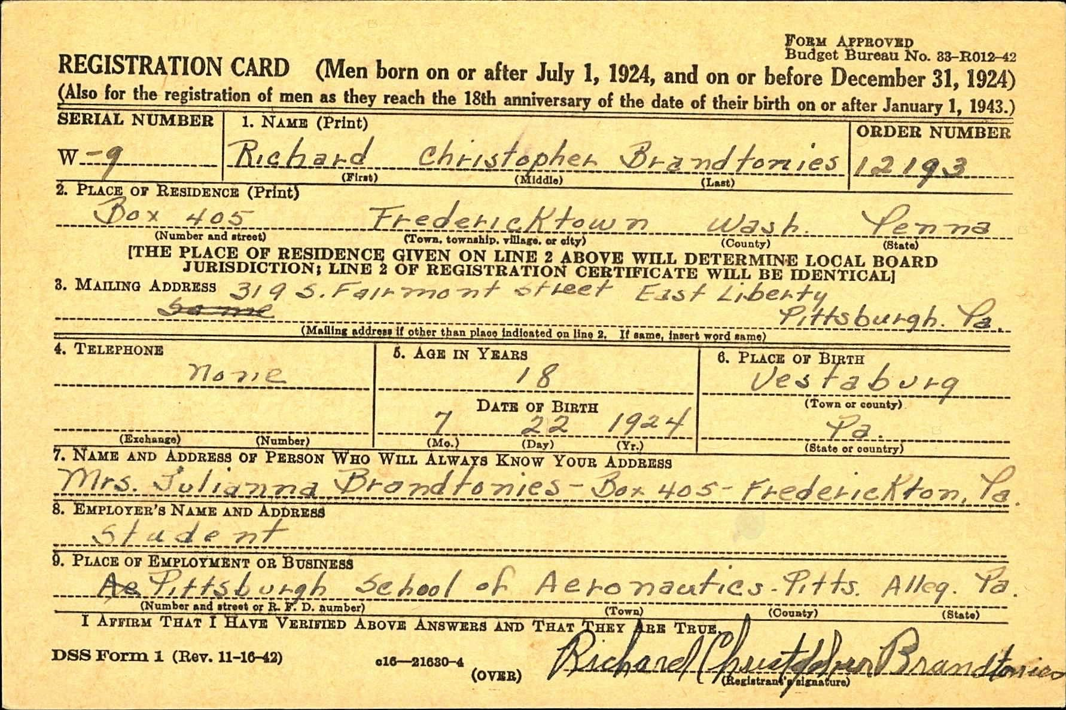
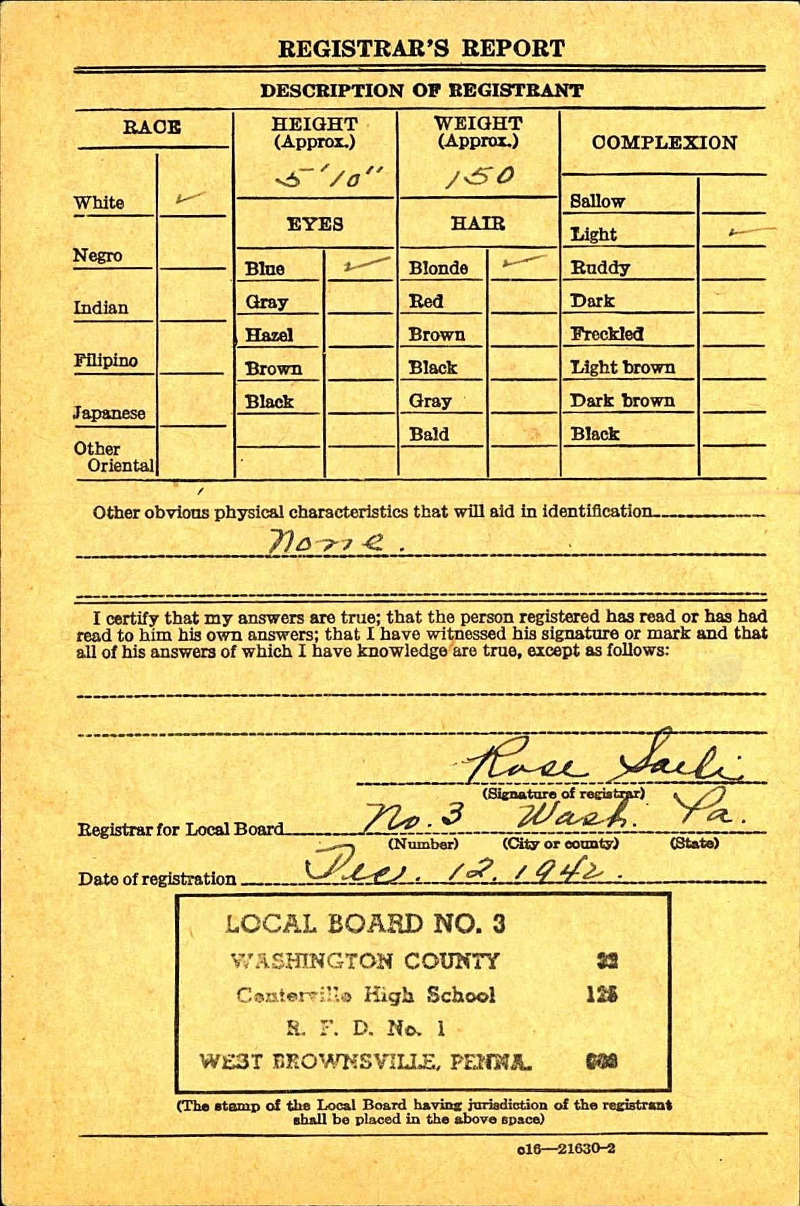
The Morning Herald Newspaper, April 7, 1939
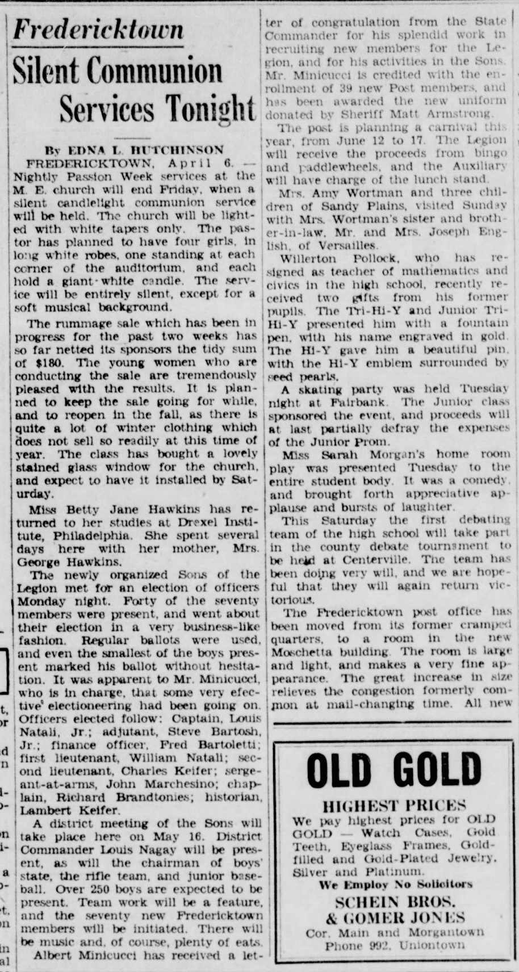

The Daily Republican newspaper, December 8, 1947
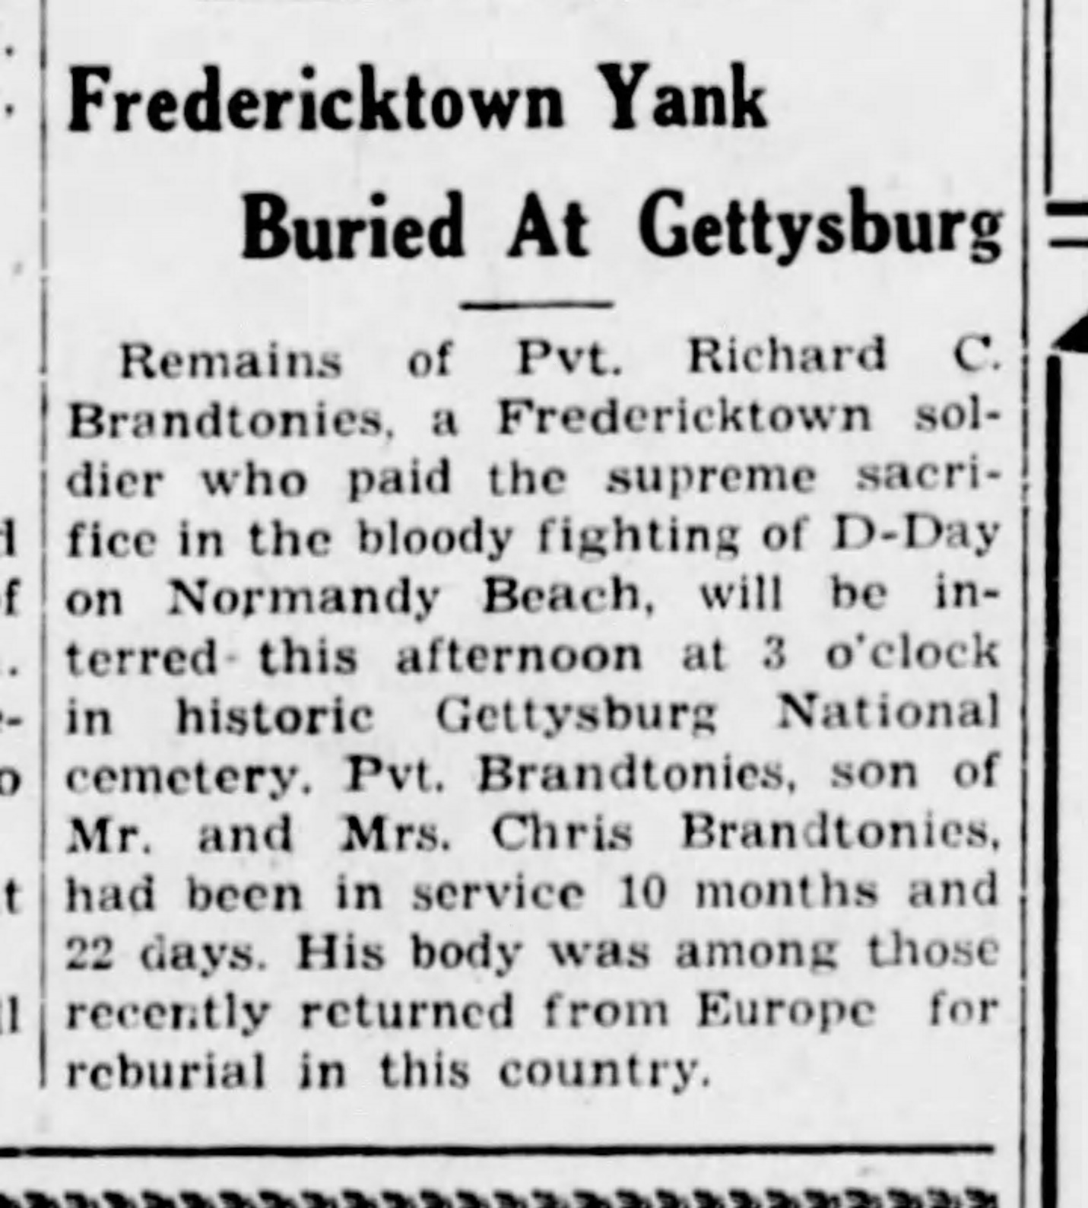

1940 Census
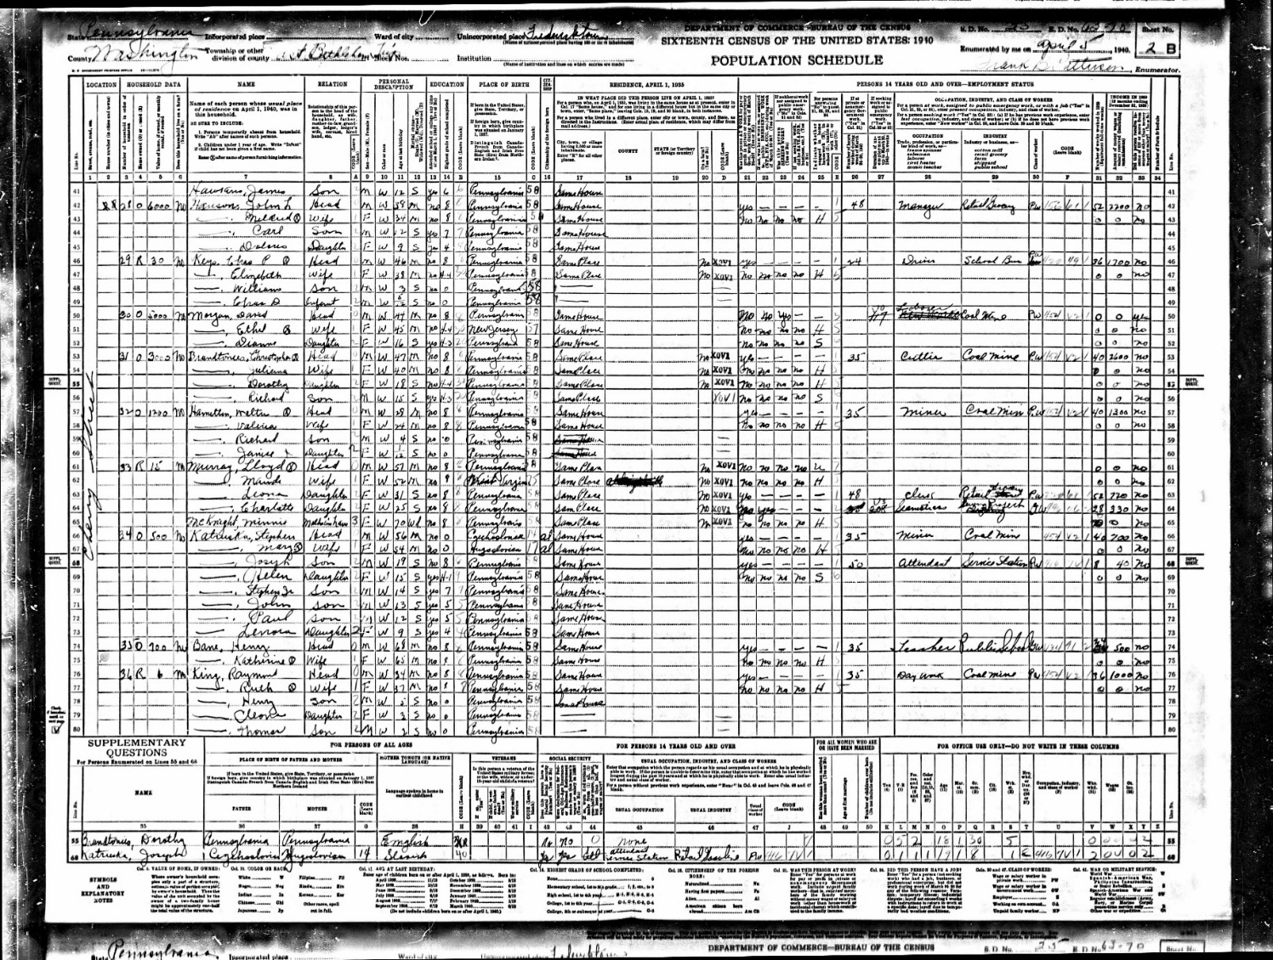

Pension Application
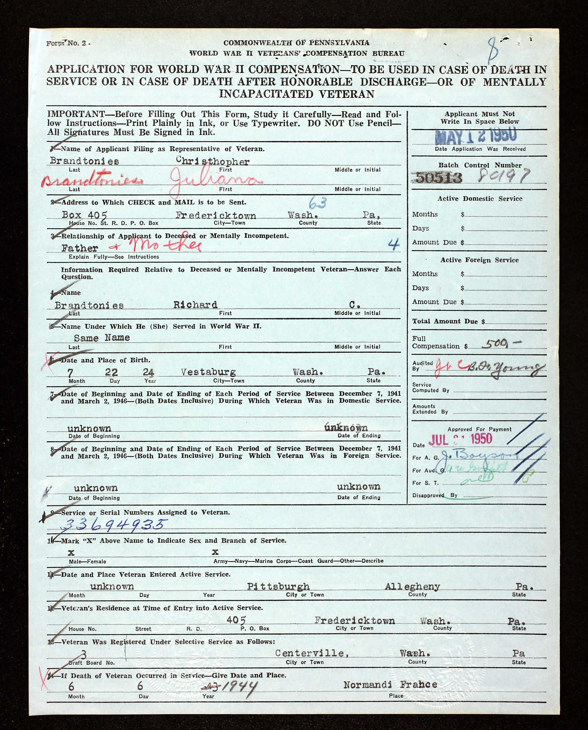

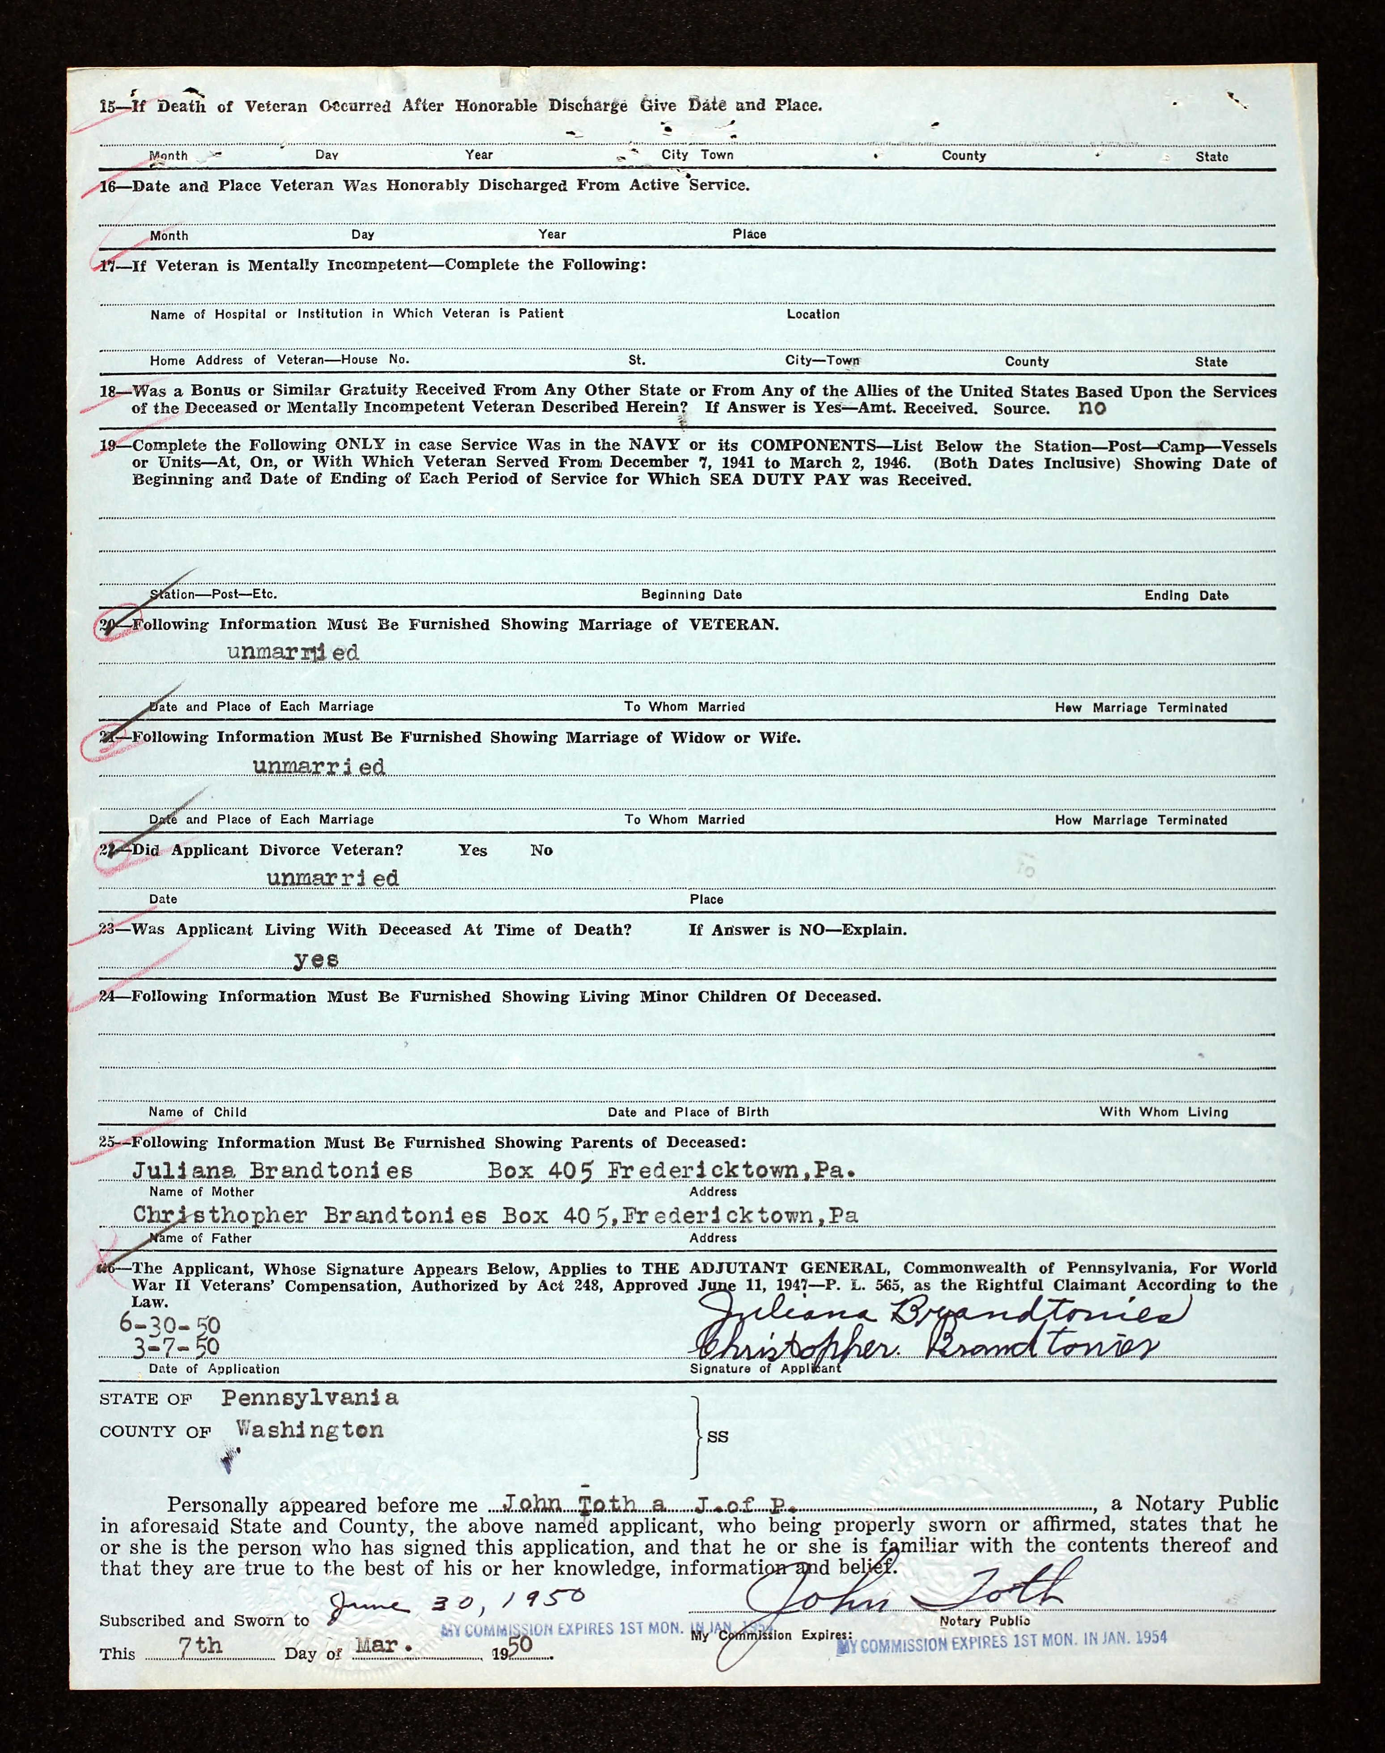

Senior High School Yearbook Photo
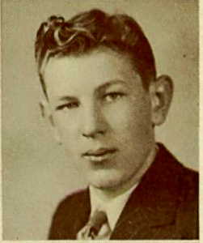

Department of Veterans Affairs Burial Card
